SUMMER RIDING CAMP 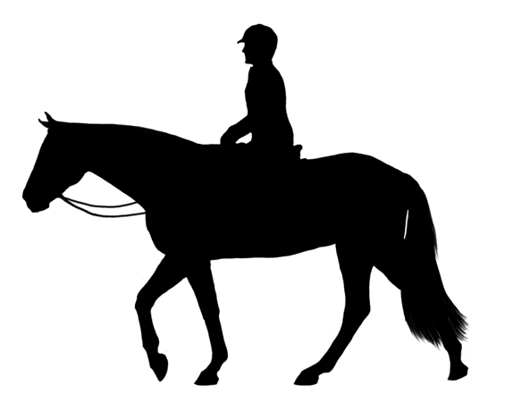

Amber Hill Farm’s Equestrian Camp program is designed
for those who desire an intensive riding experience.
We aim to help each rider achieve sound riding skills, learn proper care,
and have the personal enjoyment of working with horses on a daily basis
in a fun camp environment.
Sessions are limited to 12 Girls to ensure more personal instruction.
Residential Girls Equestrian Camp is offered in one-week sessions
for either Hunter or Eventing, for the advanced beginner to the advanced intermediate rider.

HUNTER SESSIONS Include:
- Quality instruction in Equitation, Jumping, Hunter Courses and Showing.
- Daily unmounted lessons and clinics will teach topics such as conformation, stable
management, show grooming, etc.
- Camp includes entry fees in an Amber Hill Hunter Show, (a VHSA/BHSA Associate Show), on the final day of camp.

EVENTING SESSIONS Include:
- Individualized instruction in Dressage, Cross-Country jumping and Stadium Jumping.
- Daily unmounted lessons and clinics will cover such topics as learning dressage tests,
course walking, care of the horse and the rules of Eventing.
- The final day of camp will include entry in either a camp competition or an open Amber
Hill Horse Trial.

ALL SESSIONS Include:
- Mounted lessons two times daily in addition to the unmounted classes.
- Campers will have full responsibility for their own or assigned horse, including feeding,
stall cleaning and care, which will be supervised by one of our staff.
- You may bring your own horse at no additional charge, but we do ask that the horses be
in good condition, as they will be ridden 4 – 5 hours a day, and that they are at least
started over fences.

We are very happy to help work with both you and your horse, or we have a nice
selection of horses and ponies of various levels to choose from.
While campers may be just starting to jump, they should be fairly comfortable at trot and canter.

Our Camp is completely HORSE-FOCUSED, though we usually include at least one swim and picnic at a nearby lake, and enough free time for campers to play, read or just relax. Camper’s stay in their own bunkhouse (with air-conditioning), and your horses are barn-kept for the week.

CAMP FEE PER SESSION:
$600. If enrolled Before May 1st
$650. Enrolled After May 1st

FEE INCLUDES:
Family style meals
Lodging
Lessons
Lectures
Theory Handouts
Demonstrations
Field Trips
Entry Fees for Amber Show or Horse Trials
Stall or Use of an Amber Hill Horse
Camp T-shirt

SESSIONS ARE LIMITED TO 12 GIRLS ON A FIRST-COME BASIS*
*Phone reservations are accepted, but must receive deposit within 10 days to hold
Reservation

CAMPERS NEED TO BRING THE FOLLOWING:

FOR CAMP:
Sleeping Bag
Pillow
Towels
Shampoo, Toothpaste, etc.
Flashlight
Bag for dirty clothes
Regular Clothes
Swimsuit
Rain Gear
Work Gloves (garden ok)
Water Bottle
Sunscreen/bug repellent
Spending money (soda/snacks)
Any Medications with WRITTEN Instructions

May bring a LIMITED number of snacks/drinks in CLOSED containers only – ANTS are
summer campers too!

*Please limit size and amount of personal baggage due to limited bunkhouse storage space*

Please leave cell phones, pagers, and blackberries at home.
Cell Phone use by campers is not permitted.
Phone on premises is available for use by campers at no cost (long distance included)

*A limited number of Saddles are available if you do not have your own; please consult
with Director before camp.

FOR RIDING:
Helmet (ASTM Approved)
Boots (paddock or tall)
SHOW CLOTHES
Riding clothes for daily riding (may ride in chaps or half-chaps, but no shorts)
SHOES or PADDOCK BOOTS for barn – NO SANDALS/FLIP-FLOPS allowed in Barn
Saddle
Own Grooming Equipment
Own Bathing Equipment
OWN FLY SPRAY
Tack Cleaning Kit
Polo Wraps or splint boots (any color)
Own Liniment
YARN for Braiding: Hunter – same color as mane; Event - Any color

IF YOU BRING YOUR OWN HORSE you must supply FEED for your animal, plus
your own Water & Feed Buckets, Halter, Lead and Tack. Stall and bedding only are
supplied.

PLEASE BE SURE TO MARK ALL ITEMS CLEARLY WITH YOUR NAME,
INCLUDING ALL CLOTHING AS WELL AS TACK.
Due to the LARGE number of items left each year following each camp, anyone that
requests lost & found items to be mailed to them must pay a service charge of $5.00, plus
the shipping costs, prior to the item being sent.
Any items left will be disposed of after 10 days.

ARRIVAL TIME IS BETWEEN 3:00 & 5:00 PM FOR ALL SESSIONS
PLEASE DO NOT arrive before this time
Campers will need to settle in, both themselves and their horses, by 5:00 PM.
We will go over camp rules, schedules, and get assignments. An evaluation ride will follow.
Parents are invited to visit any time during camp.

TYPICAL DAY SCHEDULE
7:00 AM: Wake up
7:30 AM: Morning Stables: Feed, clean stalls
8:30 AM: Breakfast
9:30 – 11:30 AM: Lessons
12:00 PM: LUNCH
12:30 – 1:30 PM: Break
1:30 – 3:00 PM: Unmounted Lesson/Clinic
3:00 – 4:00 PM: Break
4:30 – 6:30 PM: Lessons
7:30 PM: Dinner
8:00 PM: Evening Sables: Feed, clean stalls
8:30 – 9:45 PM: Free time/showers, etc.
10:00 PM: LIGHTS OUT

POLICY ON DEPOSITS, PAYMENTS AND CANCELLATIONS

FEE PER ONE-WEEK SESSION: $600. If ENROLLED before May 1st
$650. If ENROLLED after May 1st
DEPOSIT: A NON-REFUNDABLE Deposit of $75 must accompany Registration Forms
PAYMENT: Must be paid in full by June 25th. Payment plans available upon request.
A fee of $30 will be billed for all returned checks.
CANCELLATIONS: Deposit is non-refundable. All other payments made, less a $50
cancellation fee (in addition to deposit amount) are refundable, until 2 Weeks prior to session start date, at which point NO REFUNDS for cancellations or no shows will be made.
There will be no refunds made for a camper leaving camp during any camp session, including reasons of homesickness.
There is no reduction in fees for those campers arriving late or leaving early.
In case of serious illness or injury, with written verification from a physician, one half of the un-expired camp fee may be refunded.
Any camper found using tobacco, drugs or alcohol, or non-compliance of rules,
regulations, stipulations and conditions and/or excessively rowdy, abusive, dangerous,
immoral and/or unethical behavior toward any person or animal will be sent home
immediately, and no refund will be issued.

